Boiling Heat Transfer Exercise
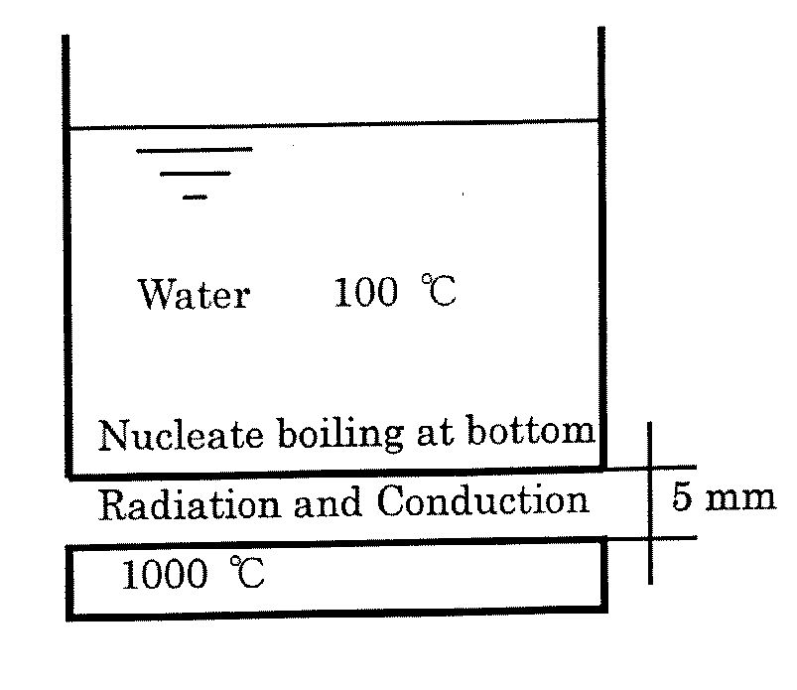
Task: Finding temperature under boiling heat transfer condition. Calculate the bottom surface temperature of the pan, neglecting resistance of the pan.
Parameters
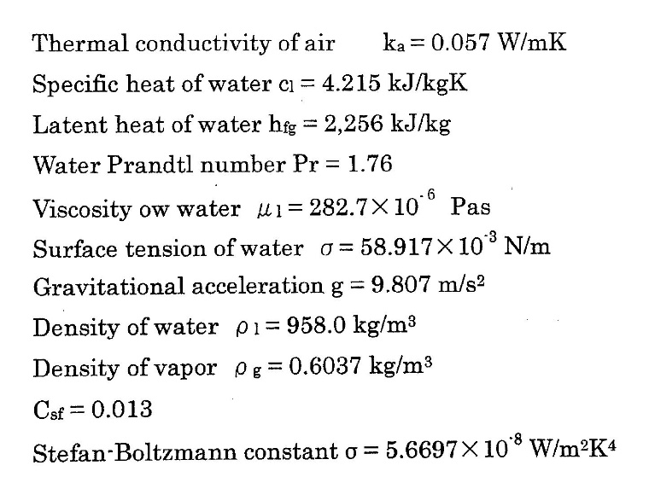
Emissivity of hot plate $ε_{1}=0.7$,
Emissivity of bottom surface of pan $ε_{2}=0.9$

Taking T1 = hot plate temperature, T2 = bottom surface of pan temperature, Tw = surface temperature of pan on water side, Ts = boiling water temperature.
Between hot plate and pan, both conduction and radiation modes of heat transfer occur in parallel.
For conduction,
$$q_{cond}=-k\frac{dT}{dx}=-k\frac{\left(T_{1}-T_{2}\right)}{δ}$$
For radiation,
$$q_{rad}=σ\left(T_{1}^{4}-T_{2}^{4}\right)\frac{1}{\frac{1}{ε_{1}}+\frac{1}{ε_{2}}-1}$$

