Question 3

- What are the mechanisms of heat transfer, and how are they different from each other?
[5 marks]

- In a manufacturing process, a transparent film is being bonded to a substrate as shown in Figure Q3. To cure the bond at a temperature T₀, a radiant heat source is used to provide a heat flux $q_{0}^{''}$(W/m²), all of which is absorbed at the bonded surface. The back of the substrate is maintained at T₁ while the free surface of the film is exposed to air at $T_{∞}$ and a convection heat transfer coefficient h.
  - Show the thermal circuit representing the steady-state heat transfer situation. Be sure to label all elements, nodes, and heat rates. Leave in symbolic form.
  - Assume the following conditions: $T_{∞}={20}^{o}C$, $h=50W/{m^{2}K}$, and $T_{1}= {30}^{o}C$. Calculate the heat flux $q_{0}^{''}$ that is required to maintain the bonded surface at $T_{0}={60}^{o}C$.
  - If the film is not transparent and all of the radiant heat flux is absorbed at its upper surface, determine the heat flux required to achieve bonding under the same conditions as part (ii).
[20 marks]
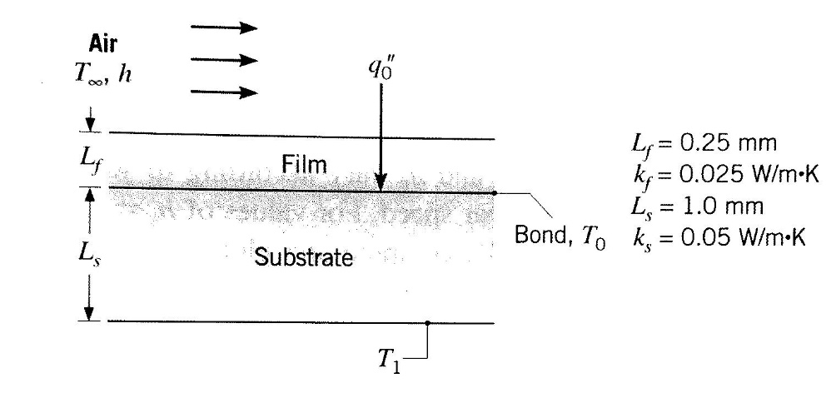Figure Q3

